VA-10
2016 IE Strategy Memorandum

Updated on 4/18/16
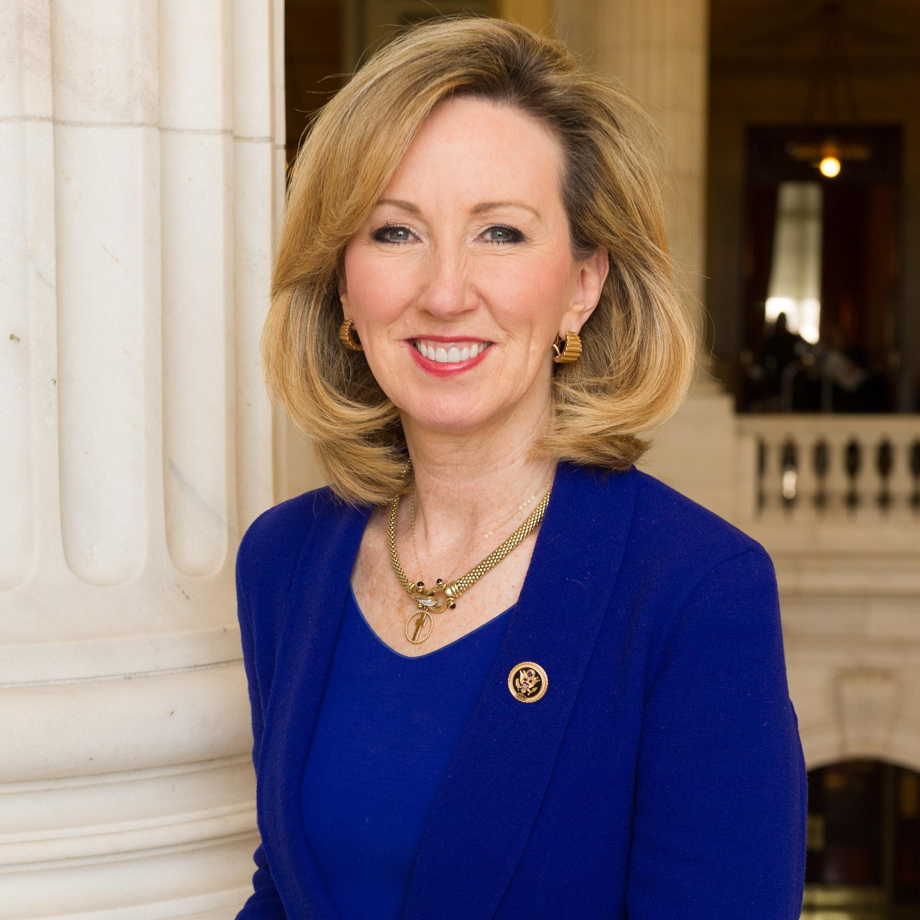


LUANN BENNETT BARBARA COMSTOCK
CoH: $554,023.17 CoH: $1,773,591.51
Date: 4/15/16 Date: 4/15/16
Occupation: Real Estate Developer Occupation: Congresswoman

SECTION I: Race Overview

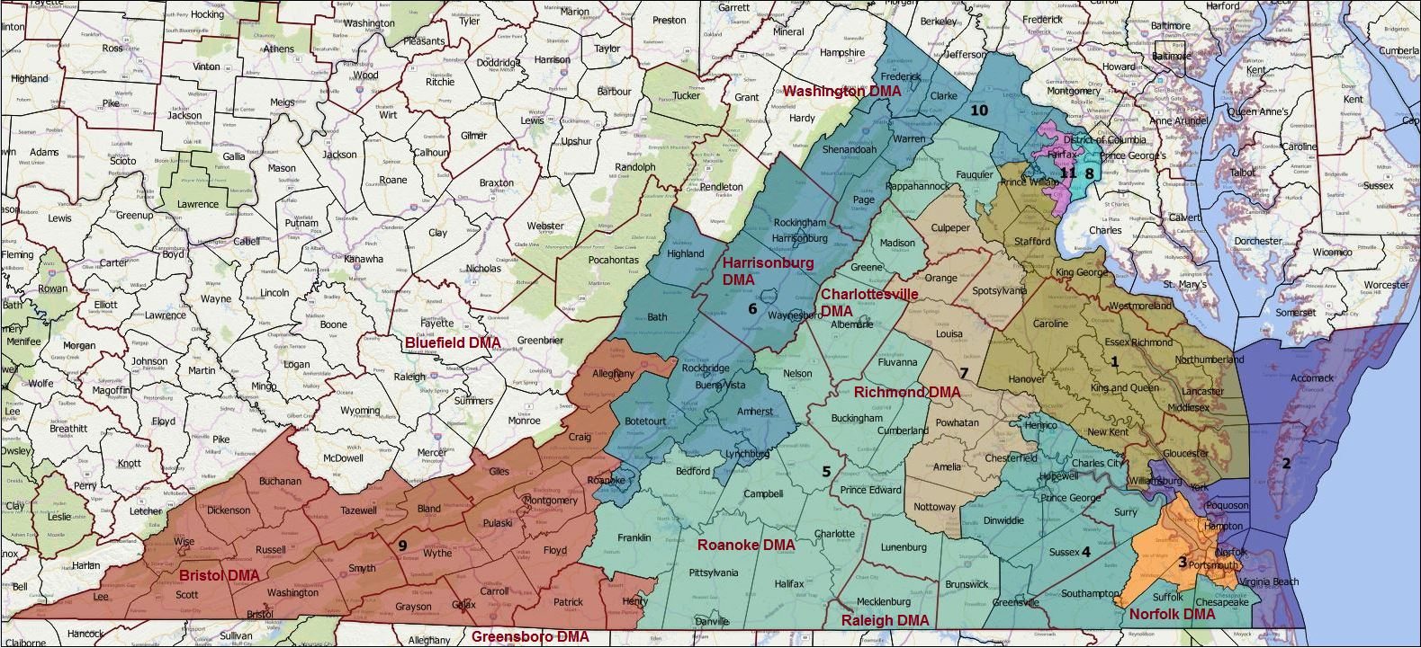
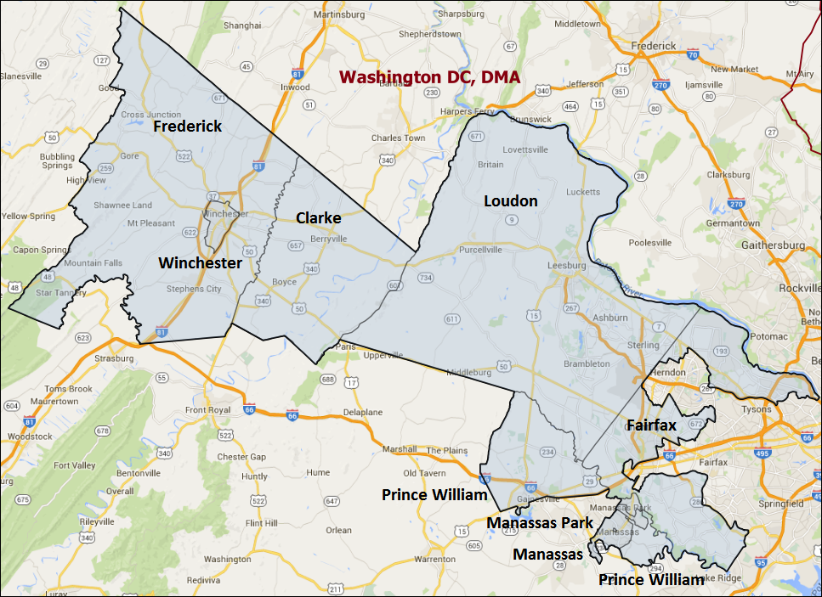
Media Market Costs

TV DMA | % of  CD | I.E.  35+ CPP | Cable CPP
WASHINGTON DC | 100% | $800 | $825
VA-10 TOTALS: | 100.0%
Radio Landscape

DMA | Universe | CPP
Washington DC | 1,091,400 | $800
Winchester | 53,500 | $32

Digital Landscape
- VA-10
  - Persuasion universe size: 59,398
  - Audience extension (key demos): Asian American Pacific Islanders, 18-45
  - Weekly budget for full coverage: $18,051.55
  - Reach
    - YouTube - 358,408
    - Pandora - 274,572

Presidential Statistics
Cycle | Candidate | Party | Vote
2012 | Obama | DEM | 50.6%
2012 | Romney | REP | 49.4%
2008 | Obama | DEM | 51.42%
2008 | McCain | REP | 48.58%

Congressional Statistics
Cycle | W/L | Candidate | Party | Vote
2014 | L | FOUST | DEM | 41.67%
2014 | W | COMSTOCK | REP | 58.33%
2012 | L | CABRAL | DEM | 39.9%
2012 | W | WOLF | REP | 60.1%

NCEC Data
Dem Performance: 48.5%
BVAP: 7.4%
Hispanic: 5.9%
Asian: 10.7%
Total Minority: 24%

Critical Dates
Primary Date: June 1

Summary of 2014 Cycle Spending by Outside Groups to Date

TV Competitive Summary – Washington DC

Campaign/Group | Total GRPs | Total Dollars
Foust/DCCC | 2,107 | $1,043,015
NRCC | 1,870 | $1,651,705
DCCC | 103 | $234,671
Patriot Majority USA | 375 | $503,182
House Majority PAC | 1,102 | $876,938
Congressional Leadership Fund | 1,182 | $1,028,496
US Chamber of Commerce | 359 | $286,781
Good Guys vs Bad Guys | Total GRPs | Total Dollars
Good Guys | 3,312 | $3,571,658
Bad Guys | 3,786 | $3,470,164

Radio Competitive Summary –Virginia – Washington DC
Campaign/Group | Total GRPs | Total Dollars
NRCC | 263 | $267,000

Good Guys vs Bad Guys | Total GRPs | Total Dollars
Good Guys | 0 | 0
Bad Guys | 263 | $267,000

Pre-Election Day Voting

Type of  “Early Voting” | Start Date  End Date | Percent of  Vote Cast Using this Method | Brief Description  (where/how  do people vote) | Timeframe (when does the majority of voting happen)
In person Absentee | Last day to vote absentee in person is Nov. 5th |  | At local registrar’s office | Rolling Basis
Absentee Mail | Must be received Tuesday before election day |  | Sent to local registrar’s office | Even rolling basis

Tentative Campaign Timeline

Please lay out the markers that your team will need to be aware of as you plan your strategy. Include markers for absentee ballots, early voting, drafting your benchmark poll, putting your benchmark poll in the field, developing your media plans and starting voter communications.

IMPORTANT DATES

In person absentee: Last day to vote in person absentee is Nov. 5th
Absentee Mail: Nov. 1 by 5:00 pm

SECTION II: DISTRICT OVERVIEW

- District Overview and Data

  - Political Landscape
- The seat is currently held by former State Delegate and Republican political operative Barbara Comstock, who won an open seat election in 2014 following the retirement of longtime Republican Congressman Frank Wolf, who was her former employer.
- LuAnn Bennett is the likely Democratic Party nominee. Bennett is a businesswomen working primarily in real estate and was married to former Rep. Jim Moran. Bennett moved to the district recently and rents an apartment in VA-10.
- A public poll in September 2015 by Harper Polling (the only poll of the district) showed the generic Democrat receiving 36% of the support to Comstock’s 49%, with the remaining 15% undecided. The poll also showed relatively high name recognition for the first term member of congress, with 45% rating Comstock favorable and 29% unfavorable. An internal DCCC poll from late March showed Bennett trailing Comstock by 15 points (29% to 44%, with 27% undecided), and Democrats trailing Republicans by 8 points on the generic congressional ballot (35% to 43%, with 22% undecided). Bennett was relatively unknown in the poll with only 22% of voters being able to rate her (8% favorable, 14% unfavorable), and Comstock is well known (64%) and popular (40% favorable, 20% unfavorable).
- 2014 With Republican Frank Wolf’s retirement, 2014 saw the first time since 1974 that an incumbent member of Congress had not been on the ballot in VA-10. Democrat and Fairfax County Supervisor John Foust closely matched Republican Barbara Comstock in fundraising, pulling in $3.0 million to Comstock’s $3.5 million. When factoring outside group spending, the two campaigns were evenly matched in paid media, with $4.3 million spent supporting Foust to $4.6 million spent supporting Comstock. Despite the large investment in the race, Foust secured only 41.7% of the two-way vote. This loss was largely due to the low turnout in the 2014 cycle. Among some of the heaviest drop offs in turnout from 2012 to 2014 were among traditionally Democratic groups: likely Democrats turned out by 34 points less than 2012, African Americans -40 points, Hispanics -44 points, and 18-29 year olds -42 points. Traditional Republican constituencies also suffered a large drop off in turnout, but not as large as the Democratic groups: Republicans turned out by 29 points less than 2012, White voters -32 points, Voters 65+ by -21 points. Senator Mark Warner fared a little bit better in this district in 2014, receiving 47.3% of the two-way vote. Warner’s support rates among Democratic demographic groups are strikingly similar to Obama’s more successful 2012 run, but those groups made up a different share of the overall electorate. In 2014, modeled Republican voters made up 47% of the electorate compared to 41% in 2012. White voters’ composition of the total vote increased to 83% from 78%, female voters dropped to 50% compared to 53% in 2012, and voters aged 18-29 dropped to 7% from 11% in 2012. Foust had a well-publicized gaffe where he attacked Comstock for “never having a real job” which led to Comstock’s campaign painting him as sexist and hurt his ability to secure the necessary margin of victory with women voters.
- Initial polling in 2014 showed Comstock with a double-digit lead ranging from 10-16 points. Foust was able to narrow the gap in late September when several polls showed the two candidates separated by 2-5 points. However, Comstock was able to regain her advantage and during the month of October when polls showed her with a 7-10 point lead.
- Comstock was able to achieve such a large victory in this district because she over-performed among several demographic groups when compared to past statewide Republican candidates in elections where the Democrat won. Comstock won by 8 points in the district, but she performed 8-12 points better among both modeled Independents and modeled Republicans than typical statewide Republicans. Comstock also performed 11-12 points better among African American voters, 12 points better among Hispanics, and 8-10 points better among Asian American voters than Republicans who narrowly lost in the district. Comstock performed 14-15 points better among voters aged 18 to 29 and 11 points better among voters aged 30 to 44 than Republicans who lost.

  - District Demographics
- VA-10 contains the suburbs of the Washington D.C. metro area in Northern Virginia. Its major population centers are Loudoun and Fairfax counties, which combined, consist of 71% of the current registered voters in the district.
- The district is primarily suburban (54.9%) and rural (33.8%). VA-10 is also very affluent and well educated. The district has a median household income of $115,291 - twice that of the U.S. median and $50,000 higher the Virginia’s. Over half its residents hold a Bachelor’s degree or higher (55.1%), 18.3 points higher than the state of Virginia.
- Asian Americans make up the largest minority group in the district consisting of 10.7% of the citizen voting age population, followed by African Americans (7.4%), and Hispanics (5.9%). Loudoun and Fairfax are key areas of concentration for the Asian American population, and Manassas City, Manassas Park, Winchester, and Prince William Counties are key areas of concentration for African Americans and Hispanics. From 2012 to present day, Asian Americans have increased from 6.7% of all registered voters to 8.9%, a sign of how quickly this group is growing in the region.
- The state of Virginia does not have party registration. Any references to partisanship in the district come from modeling. Voters scored above 70 are considered Democrats, voters scored below 30 are considered Republicans, and voters scored between 30 and 70 are considered Independents.

District Demographics

- Cook Partisan Voting Index: Lean Rep
- Urban Population: 11.3%
- Rural Population: 33.8%
- Suburb Population: 54.9
- Median Income: $115,291
- Poverty Status: 3.1%
- Military Veterans: 10.3%
- Race/Ethnic Origin: 65.5% White; 7.4% Black; 10.7% Asian; 5.9%

  - Electoral Context
- There is a “right to work” ballot initiative to be on the ballot in 2016, which would likely affect progressive organization investment in the state.
- In 2014, Virginia instituted mandatory voter ID. There are many options for the IDs that voters can bring to the polls, and Virginia provides free voter photo IDs in cases where voters do not possess an ID.
- Virginia, and northern Virginia in particular, will likely be a key battle ground state and region during the 2016 presidential election. If Virginia is competitive at the presidential level during the general election, much of the district is likely to be a significant persuasion target for both Democratic and Republican 2016 presidential campaigns. A Democratic presidential campaign does not necessarily need to win VA-10 to win Virginia’s electoral votes, but they do need to keep the two-way vote very close in the district. It is also worth noting in 2012 out of all of Virginia’s congressional districts VA-10 had the 4th highest number of Obama IDs. It currently has the largest persuasion universe for a statewide campaign, and in 2012, it contributed 4th most to Obama’s vote total.
  - Press Presence
- The district is covered entirely by the Washington D.C. media market, which currently has an estimated cost per point of $800 for issue ads.
- VA-10 will be covered by Northern Virginia and D.C. media outlets alike.

SECTION III: MESSAGE

Message Box

Democrat Self Frame  LuAnn has faced down tough challenges, always emerging stronger. She knows that Northern Virginia has done the same – in the face of government shutdown and traffic gridlock, booming growth and recession. LuAnn will be a strong leader for Virginia’s 10th Congressional District, putting people over politics and fighting for a better future. | Republican Self Frame  Barbara Comstock is a principled, common sense conservative leader who has worked tirelessly to tackle Northern Virginia’s most difficult challenges. She has focused on creating a healthy economy, providing 21st century jobs and expanding and promoting our technology community. She will work to repeal and replace Obamacare, pass meaningful tax relief for families and small businesses and protect our national security.
Likeliest Attacks on Democrat  LuAnn Bennett is a DC-elite, district shopping carpetbagger that is weak on the issues. | Best Attacks on Republican  Comstock is a partisan Republican who is too extreme for Northern Virginia, especially on women’s health rights in this pro-choice district. Comstock repeatedly voted to cut transportation priorities in Northern Virginia and she now wants to takes credit for Silver Line. Comstock can’t get her Republican colleagues to invest in Northern Virginia transportation infrastructure that is not keeping up with rapid growth Comstock is an anti-choice, anti-immigrant incumbent whose priorities are out of line with Northern Virginians.

- LuAnn Bennett

- Short Biography
Over the last 35 years, LuAnn Bennett has raised a family in Northern Virginia and grown a thriving small business. The middle of three children, LuAnn grew up on her family’s working farm in Highland, Illinois. LuAnn lost her husband Rick to leukemia in 1994. His sudden passing left her a single mom of three young boys, and left their business in a difficult financial position. She continued to build the real estate company into the success it is today.

- Self-Frame
LuAnn has faced down tough challenges, always emerging stronger. She knows that Northern Virginia has done the same – in the face of government shutdown and traffic gridlock, booming growth and recession. LuAnn will be a strong leader for Virginia’s 10th Congressional District, putting people over politics and fighting for a better future.

- Likely Attacks
Inexperienced
Wealthy DC-Elite
District Shopping
Doesn’t Take/Know Issue Positions

- Assessment of Democratic Fundraising
MEMBER/CANDIDATE | CYCLE RAISED | CYCLE SPENT | Q1 RAISED
LuAnn Bennett | $700,163.50 | $146,140.33 | $418,814.34

- Strengths and Weaknesses of Campaign

Strengths: LuAnn has the right profile for this moderate district. Her background as a small business owner who knows how to get things done will be beneficial. In addition, she is likely to have the resources to communicate at a high level in what will be a very expensive race.

Weaknesses: LuAnn is a first time candidate who needs to get more comfortable talking about policy and her reason for running. This district is comprised of a very well informed electorate and she will not be able to get by with just her bio. Though she rents an apartment in VA-10, the NRCC has been saying that LuAnn Bennett is a DC insider who still lives in a $1.35 million condo at the Ritz Carlton in DC. The NRCC also points to LuAnn Bennett’s mansion in VA-05 to say she does not have ties in the 10th district

- Barbara Comstock

- Short Biography
As a Young Married Couple looking for the best place to work and raise a family, the Comstock first came to McLean in 1981 when Barbara’s husband, Chip, started teaching at Langley High School. They’ve raised their three children here. Before running for congress, Comstock was an aide to Congressman Frank Wolf and a Senior Justice Department Official, and a state house delegate in Virginia.

- Self-Frame
Barbara Comstock is a principled, common sense conservative leader who has worked tirelessly to tackle Northern Virginia’s most difficult challenges. She has focused on creating a healthy economy, providing 21st century jobs and expanding and promoting our technology community. She will work to repeal and replace Obamacare, pass meaningful tax relief for families and small businesses and protect our national security.

- Best Attacks

Republican Candidate | Ryan Budget(s) – (Include if its Votes or Statement) | Privatize Social Security | Defund Planned Parenthood | Anti-Choice Position
Barbara Comstock | Defended Ryan Budget | Voted to jeopardize social security | Yes | Yes

Comstock Top Hits
- Endorsed Marco Rubio, has not endorsed another presidential candidate after he dropped out.
- Comstock accepted but later returned a $3000 donation from Donald Trump.
- Withdrew support from bipartisan bill to fund breast cancer awareness because funding might help Planned Parenthood.
- Compared tracking immigrants to tracking FedEx packages.
- Accused of being a “recent convert” to silver line funding.
- Has been a part of the Republican machine in several capacities as lobbyist, Bush appointee, and was called a “professional Clinton hater.”
- See “The Case Against Barbara Comstock” In VA-10 research book.
- See “Barbara Comstock One Pager”.

SECTION V: Appendix

- 2016 Campaign Side Consulting Team
- Media: Dixon Davis
- Mail: Alan Moore
- Polling: BSG
- Online/Digital:
- Self-research:

- Summary of Past Races and Important Differences for 2016
With Republican Frank Wolf’s retirement, 2014 saw the first time since 1974 that an incumbent member of Congress had not been on the ballot in VA-10. Democrat and Fairfax County Supervisor John Foust closely matched Republican Barbara Comstock in fundraising, pulling in $3.0 million to Comstock’s $3.5 million. When factoring outside group spending, the two campaigns were evenly matched in paid media, with $4.3 million spent supporting Foust to $4.6 million spent supporting Comstock. Despite the large investment in the race, Foust secured only 41.7% of the two-way vote. This loss was largely due to the low turnout in the 2014 cycle. Among some of the heaviest drop offs in turnout from 2012 to 2014 were among traditionally Democratic groups: likely Democrats turned out by 34 points less than 2012, African Americans -40 points, Hispanics -44 points, and 18-29 year olds -42 points. Traditional Republican constituencies also suffered a large drop off in turnout, but not as large as the Democratic groups: Republicans turned out by 29 points less than 2012, White voters -32 points, Voters 65+ by -21 points. Senator Mark Warner fared a little bit better in this district in 2014, receiving 47.3% of the two-way vote. Warner’s support rates among Democratic demographic groups are strikingly similar to Obama’s more successful 2012 run, but those groups made up a different share of the overall electorate. In 2014, modeled Republican voters made up 47% of the electorate compared to 41% in 2012. White voters’ composition of the total vote increased to 83% from 78%, female voters dropped to 50% compared to 53% in 2012, and voters aged 18-29 dropped to 7% from 11% in 2012. Foust had a well-publicized gaffe where he attacked Comstock for “never having a real job” which led to Comstock’s campaign painting him as sexist and hurt his ability to secure the necessary margin of victory with women voters.
Initial polling in 2014 showed Comstock with a double-digit lead ranging from 10-16 points. Foust was able to narrow the gap in late September when several polls showed the two candidates separated by 2-5 points. However, Comstock was able to regain her advantage and during the month of October when polls showed her with a 7-10 point lead.
Comstock was able to achieve such a large victory in this district because she over-performed among several demographic groups when compared to past statewide Republican candidates in elections where the Democrat won. Comstock won by 8 points in the district, but she performed 8-12 points better among both modeled Independents and modeled Republicans than typical statewide Republicans. Comstock also performed 11-12 points better among African American voters, 12 points better among Hispanics, and 8-10 points better among Asian American voters than Republicans who narrowly lost in the district. Comstock performed 14-15 points better among voters aged 18 to 29 and 11 points better among voters aged 30 to 44 than Republicans who lost. Perhaps most notably since they make up 52% of the registered voters in the district, Comstock performed 9-12 points better among women than past statewide Republicans. Geographically Comstock’s share of the two-way vote was much larger than expected when compared to candidate specific modeling in Fairfax County, the Manassas area, Prince William County, Fredrick County, and north Loudon County.

Role of the I.E.
Initial benchmark showed Comstock in a strong position to win, with voters harboring positive opinions toward her. Interestingly, we learned that messaging on social issues (the combination of abortion, gun rights and same-sex marriage), particularly Roe v. Wade, was the only thing that could put this race in play. Since the DC media market was incredibly expensive, we ran a digital persuasion program from Week 7 to Week 3. We hoped that our digital communications would amplify advertising from Foust (including 441AD) – and put this race into play late in the cycle. Simply put, this district was too expensive for the IE to carry – our only viable role could be to put Foust over the top if the election was already close.
Targets in 2016
- Applying that turnout rate forward to the 2016 electorate, we can expect to see 73.6% of registrants turn out, casting 375,421 total votes, again, relying on the latest registration statistics from the Secretary of State.
- To reach a goal of 52% support overall, a successful campaign would need at least 195,219 raw votes. A one-point shift in support equates to 3,754 raw votes.
- Because of the increased presidential cycle turnout, the 2016 the electorate will contain larger shares of some key demographics. The 2016 electorate as a whole will be made up of 5 points more minority voters, 4 points more voters aged 18-29, and 3 points more female voters. In terms of partisan modeling, the 2016 election cycle will likely be made of 7 points more modeled likely independents, and 8 points less modeled likely Republicans.
- During the 2012 election, 7,469 (2.0%) voters cast a vote for President but not in the Congressional race. More significantly, 40,408 voters voted for President Obama in 2012, but did not support the Congressional Democratic Party nominee, and the Republican Congressional nominee received 27,388 more votes than Mitt Romney. However, the 2012 Democratic Congressional campaign in VA-10 was not significantly competitive, and serves as a less-than-perfect input to project major party ticket splitting in 2016. In 2014 the rolloff was much lower down from the competitive U.S. Senate race to the competitive U.S. House race with 223,283 voters casting a ballot in the Senate race and 222,914 casting a ballot in the House race. This equals a rolloff 0.2%
- When looking at initial targets for the 2016 election based on preliminary national turnout and support modeling, base voters are most heavily concentrated in Manassas, Manassas Park, Fairfax, and northern Loudon Counties. Persuasion targets are most heavily concentrated the central section of the eastern part of Loudon Count,, and Fairfax County. Turnout targets are most densely concentrated in eastern Loudon County, and Fairfax County. The fact that Loudon and Fairfax have heavy concentration of all these targets highlights their importance to being successful here, and indicates that a campaign should engage in both persuasion and turnout activities.

- Current Needs
b-roll & stills

